Name: Dodeja Yogesh Ghanshyambhai

Subject: HTML- CSS Assignment 2

Faculty: Heet Modh

1. Are the HTML tags and elements the same thing?

* No HTML tags are used to hold the HTML element HTML element holds the content.

Ex: <div></div> This is HTML tag

<div>Yogesh</div>This is HTML element

2. What are tags and attributes in HTML?

* HTML tags are used to hold the HTML element HTML attributes are used to describe

The characteristics of an elements

* It is the keyword who defines the content elements
* Ex: <html>….</html>
* The HTML attributes provides additional information of elements
* Ex: <a href= “” > </a>

3. What are void elements in HTML?

* Void element is an element whose content model never allows it to have contents under any circumstances
* <br>
* <hr>

4. What are HTML Entities?

* HTML entities is a piece of text (string)that begins with an ampersand

(&nbsp;)

(&amp;)and ends with a semicolon()

5. What are different types of lists in HTML?

There are three types of list.

* Unordered list or Bulleted list (ul)
* Ordered list or Numbered list (ol)
* Description list or Definition list (dl

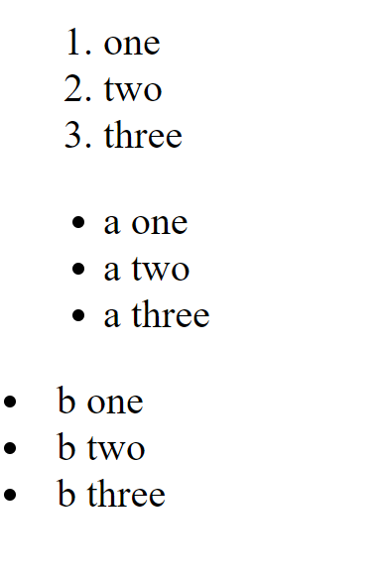

6. What is the 'class' attribute in HTML?

* The class attribute specifies one or more class names for an element. The class attributes

Is mostly used to point to a class in style sheet

Ex: <div class= one></div>

7. What is the difference between the 'id' attribute and the 'class' attribute of HTML elements?

* A class name can be used by multiple HTML elements while an ID name must only be used by one HTML elementwithin the page

Ex: <div class= one></div>

<div id= one></div>

8. What are the various formatting tags in HTML?

* <b>- Bold text
* <strong>- Important text
* <i>- Italic text
* <em>- Emphasized text
* <mark>- Marked text
* <small>- Smaller text
* <del>- Deleted text
* <ins>- Inserted text
* <sub>-Subscript text
* <sup>- Superscript text

9.How is Cell Padding different from Cell Spacing?

* Cellpadding specifies the space between the border of a table cell and its contents (1.e) it defines the whitespace between the cell edge and the content of the cell.

Syntax:

<table cellpadding="value" >.....Cellspacing:..</table>

Cellspacing

Specifies the space between cells (i.e) it defines the whitespace between the edges of the adjacent cells.

Syntax:

<table cellspacing-"value" >.....</table>

10 How can we club two or more rows or columns into a single row or column in an HTML table?

* It can be done by using the rowspan and colspan attribute in HTML. The rowspan is used to merge or combine the number of cells in a row whereas the colspan is used to merge column cells in a table
* Example

<!DOCTYPE html>

<html lang="en">

<head>

<meta charset="UTF-8">

<meta http-equiv="X-UA-Compatible" content="IE=edge">

<meta name="viewport" content="width=device-width, initial-scale=1.0">

<title>Document</title>

</head>

<body>

<table border="1">

<tr>

<td colspan="6" align="center">Time Table</td>

<!-- <td>2</td>

<td>3</td>

<td>4</td>

<td>5</td>

<td>6</td> -->

</tr>

<tr>

<td rowspan="6" align="center">hours</td>

<td>mon</td>

<td>tue</td>

<td>wed</td>

<td>thu</td>

<td>fri</td>

</tr>

<tr>

<td>math</td>

<td>sci</td>

<td>math</td>

<td>sci</td>

<td>arts</td>

<!-- <td>6</td> -->

</tr>

<tr>

<td>math</td>

<td>sci</td>

<td>math</td>

<td>sci</td>

<td>arts</td>

<!-- <td>6</td> -->

</tr>

<tr>

<td colspan="6" align="center">lunch </td>

<!-- <td>2</td>

<td>3</td>

<td>4</td>

<td>5</td>

<td>6</td> -->

</tr>

<tr>

<td>math</td>

<td>sci</td>

<td>math</td>

<td colspan="2" rowspan="2">project</td>

<!-- <td>5</td>

<td>6</td> -->

</tr>

<tr>

<td>math</td>

<td>sci</td>

<td>math</td>

<!-- <td>4</td>

<td>5</td>

<td>6</td> -->

</tr>

</table>

</body>

</html>

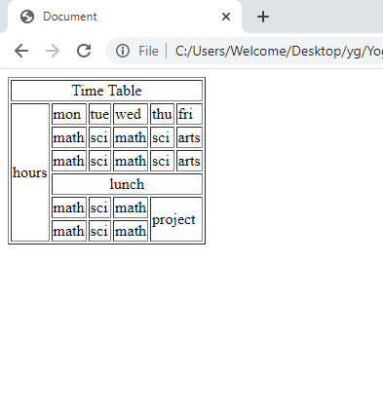

11 What is the difference between a block-level element and an inline element?

A block-level element always starts on a new line, and the browsers automatically add some space (a margin) before and after the element.

A block-level element always takes up the full width available (stretches out to the left and right as far as it can).

Two commonly used block elements are: <p> and <div>.

Inline -Element

These elements dose not start with new line and take width as per requirement

Inline elements : <a> <label> <b>

12.How to create a Hyperlink in HTML?

* Hyperlinks are a set of anchor tags that are used to point to another HTML file, text, audio, video, webpage, etc. Basically, a hyperlink is what makes a web.

<a href="https://www.google.com/">Visit google.com!</a>

13. What is the use of an iframe tag?

The <iframe> tag specifies an inline frame. An inline frame is used to embed another document within the current HTML document.

Ex: <iframe src="demo_iframe.htm" style="height: 200px; width:300px; title="Iframe Example"></iframe>

14. What is the use of a span tag? Explain with example ?

The <span> tag is an inline container used to mark up a part of a text, or a part of a document. The <span> tag is easily styled by CSS or manipulated with javascript using the class or id attribute

Ex: <p>My mother has <span style="color:blue">blue</span> eyes </p>

15 How to insert a picture into a background image of a web page?

The most common & simple way to add background image is using the background image attribute inside the <body> tag

Background-image: url('img_girl.jpg');

16 How are active links different from normal links?

The default color for normal and active links is blue. Some browsers recognize an active link when the mouse cursor is placed over that link; others recognize Activate Windows

17 What are the different tags to separate sections of text?

<br> tag-Usually <br> tag is used to separate the line of text. It breaks the current line and conveys the flow to the next line

<p> tag-This contains the text in the form of a new paragraph.

<blockquote> tag-It is used to define a large quoted section

18 What is SVG?

SVG stands for Scalable Vector Graphics.

SVG defines vector-based graphics in XML format.

<svg width="100" height="100">

<circle cx="50" cy="50" x="40" stroke="green" stroke- width="4" fill="yellow" />

</svg>

</body>

</html>

19 What is difference between HTML and XHTML?

HTML is the standard markup language for creating web pages, while XHTML is a

Stricter and more standardized version of HTML

20 What are logical and physical tags in HTML?

Physical and Logical tags are used in HTML for better visibility and understanding of the text by the user on the web page.

Logical tags<strong><del> <Ins>Physical tag <strong> <sub><sup>